Did you know that by using Gift Aid you could make your donation worth even more? For every pound you give to us, we get an extra 25p from the Inland Revenue…All you have to do is fill in this form and sent it back to us at FREEPOST NUH CHARITY (you don’t need to write anything else on the envelope and you don’t need a stamp)

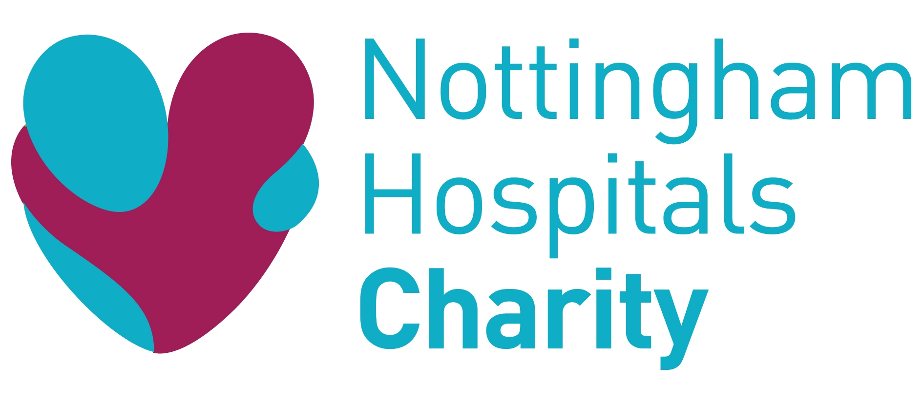
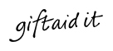

GIFT AID DECLARATION

Please treat

My Gift as a Gift Aid donation; OR

All gifts of money that I make today and in the future as Gift Aid donations; OR

All gifts of money that I have made in the past 4 years and all future gifts of money that I make from the date of this declaration as Gift Aid donations.
ü Please tick the appropriate box

I am a UK taxpayer and understand that if I pay less Income Tax and/or Capital Gains Tax in the current tax year than the amount of Gift Aid claimed on all my donations it is my responsibility to pay any difference.
Title: ______Initial(s): ______Surname: ___________________________

Home address: ______________________________________________
___________________________________________________________
___________________________________________________________
___________________________________________________________

Postcode: ________________________Date:_____________________

Signature: _________________________________________________

It is your responsibility to notify the charity if you:

- Want to cancel this declaration
- Change your name or home address
- No longer pay sufficient tax on your income and/or capital gains

If you pay Income Tax at the higher or additional rate and want to receive the additional tax relief due to you, you must include all your Gift Aid donations on your Self Assessment tax return or ask HM Revenue and Customs to adjust your tax code.

